Shoreline Middle School Parent Advisory Council (PAC) Meeting Agenda
Date: February 17th, 2026
Time: 6:30 PM
Location: School Library
Attendance: Karen Walsh, Fiona Anderson, Carolynne Clark, Alissa Moore, Michelle Newman-Bennett, Andrew Poucher, Brian Kirke, Myra James

1. Call to Order and Land Acknowledgement (6:30 PM)
(Land acknowledgement by Fiona)

2. Approval of Agenda
Motion to adopt approved

3. Approval of Minutes
- Review and approval of minutes from the last meeting

4. Reports (6:40 PM)
- Chairperson’s Report - Updates since January PAC meeting; News and announcements-Gr. 7 teachers request for funds ($1200) to support Camp Thunderbird
- Treasurer’s Report - Bank account balances; Financial updates $18000, fundraising needs $3400 to cover projected spending, $2200 spent so far, budget has been mainly allocated for the year but some flexibility remains: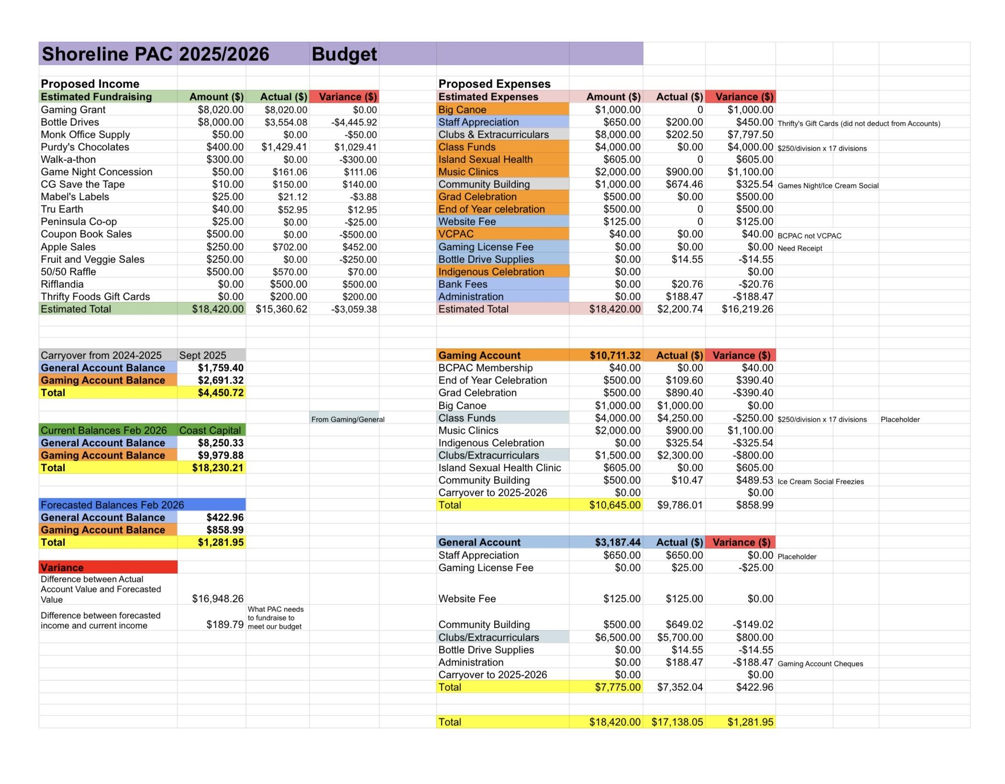
- Administrators’ Report - School updates and announcements: Jesse Schroeder has been giving presentations about online safety, Carey from Rainbow kitchen who support our “Fridge of Love” free snack program came to school and would like feedback on what students like and how they use the fridge, Diane the accountant is back and getting caught up on new systems, newsletter continues to be updated, Alex Tiller working on Gr.8 band trip, Shoreline hosting Lahal tournament this March (first ever Lahal middle-school tournament in Victoria!)
- Fundraising Committee - Bottle Drives March 7th, 2026, 10am-1pm supported by and benefitting Shoreline Student Council, can we change the sign on the corner of Shoreline Drive and the Island Highway that says “fields closed” to advertise for the bottle drive; Purdy's Fundraiser for March (Easter weekend: April 3–6) share on newsletter email, facebook; Ongoing Fundraisers: Country Grocer Receipts, Peninsula Co-op # 154268, Tru-Earth; 50/50 Draw at Band Concert – Recap
- VPAC Representative - Updates from VPAC, Parent info session tomorrow night at S.J.Willis, Thursday night at Arbutus with Monique Moore
- Motion to cancel google suites and web-domain, seconded and carried

5. Unfinished Business (7:00 PM)
- Teacher Appreciation March 12th, 2026 Alissa to provide Carolyn with numbers and dietary restrictions of all staff 51, Mr.Poulin is retiring in 3 weeks PAC to give a retirement gift?
- Teacher Fund Applications
- Mr Morrison – librarian asking $100 book prizes, Motion approved
- Ms.Christy requesting $1200 to subsidize Camp Thunderbird, Motion Approved
- Shoreline Gear for Grade 5 (to be discussed at April meeting)
- Payments/Teacher submissions for funds from bottle drives vs grant
- 50/50 to be organized-Let Alex Tiller know that we want to run 50/50 at the concerts on Monday and Tuesday, prize to be claimed AFTER the concert ends

6. New Business (7:10)
- Mr.Poulin retirement gift card for $50.00 approved
- Criminal Record checks-not needed to be on the PAC, (only if parents are alone with kids)
- Great little coupon book $15/book PAC gets $7.50/book launch at concert? Decision made to not participate this year
- motion to forgone March PAC meeting as it is a short month and busy time of year (not necessary)-motion carried
- Motion to move meeting April meeting to the 21st-motion carried

7. Next Meeting
- Date: April 21st, 2026 (same night but after student led conferences)
- Location: Online option – link TBD

8. Agenda Items for Next Meeting (7:35 PM)
- 50/50 Band Concert recap
- Teacher appreciation
- Teacher funds

9. Adjournment 7:48pm

